15-112 Term Project: Competitive Analysis

Edric Kusuma (ekusuma)

Section M

I. Similar Products

1. osu! (<http://osu.ppy.sh/>)

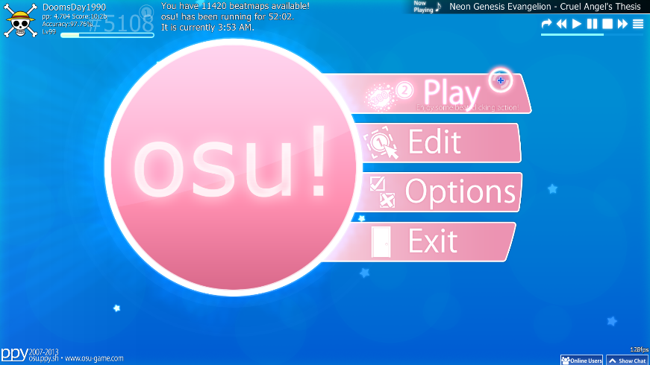

UI: menu

(Picture Credit: <http://static.giantbomb.com/uploads/original/18/184163/2547532-osumainmenu.png>)

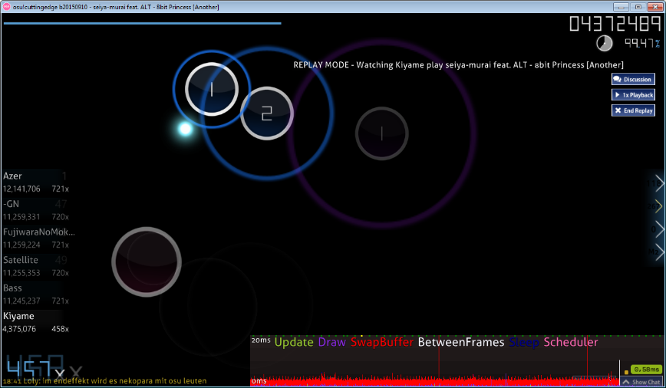

Core gameplay – click the circles

(Picture Credit: <https://goo.gl/jDWBv4>)

Liked Features:

* Very simple UI and menu
* Fast-paced, fun gameplay of “clicking the circles” to the rhythm
* Variety of music to play; if popular, likely on the beatmap repository

Disliked Features:

* Maps are user-created
  + Thus can only play songs another user has made a map for
* Incredibly unforgiving (one or two mistakes lead to a fail)
* With practice, beatmaps become predictable (less about skill, more about memorizing beats)

osu! is one of the most popular free to play rhythm games on computer, which is by no small part due to the immensely large repository of user-generated maps. The gameplay is very simple: click the circles in line with the rhythm, and score points. While it occasionally gets more complicated with things like dragging circles and spinners (where the use has to—surprise surprise—spin the spinner with the mouse). That being said, with this simple core gameplay, the game does get very difficult, with fast-paced levels (called “beatmaps”) that have the user click away at circles quickly, and often have them move the mouse all across the screen (“jumps”) to hit the next circle.

Having the beatmaps be user-generated has its disadvantages. For example: if there is a song the player wishes to play, but isn’t too popular, chances are the beatmap doesn’t exist, and if it does it is usually a sub-par submission by another user. If the beatmaps were generated based on the player’s own music, then they can play any track, regardless of whether or not a user has created a beatmap.

Additionally, because beatmaps are pre-generated, every playthrough of a song will be identical to previous ones. With a lot of practice, playing a beatmap becomes more about memorizing each section of the song instead of on the fly skill and “sight-reading”. While this is not so much of a negative point (beatmaps remain hard regardless, and it does create a sense of satisfaction when one a tough one is cleared), it remains predicable nonetheless. By randomly generating a beatmap, this predictability is gone. Each run of the song is unique, and keeps the player on their toes.

Finally, osu! has a reputation of being notoriously unforgiving. With the higher-difficulty beatmaps, missing one or two notes often leads to a fail of the entire song. Especially when the song is a long one, this failure can be frustrating to many. Again this feature does incite a greater feeling of satisfaction, but to new or unskilled players it can be infuriating to play.

I intend to incorporate the core gameplay of osu! to my term project. The act of clicking buttons to the rhythm is simple, but very enjoyable. In terms of difficulty and beatmap generation, however, I aim to take a different approach. I want to make the maps randomly generated based on the beats of the song (using librosa to perform beat analysis). To keep this fair, I’m considering putting a bias in the direction of each beat. For example, if a beat is generated near the edge of the screen, the next one will be generated in the general direction of the center. What I want to change is the fail mechanic. I want to make it harder to fail (but still possible), with the main penalty coming from a score penalty. If the player’s combo is broken (combo being the consecutive beats hit), then the multiplier is reset and the player’s score increments much more slowly.

1. Audiosurf

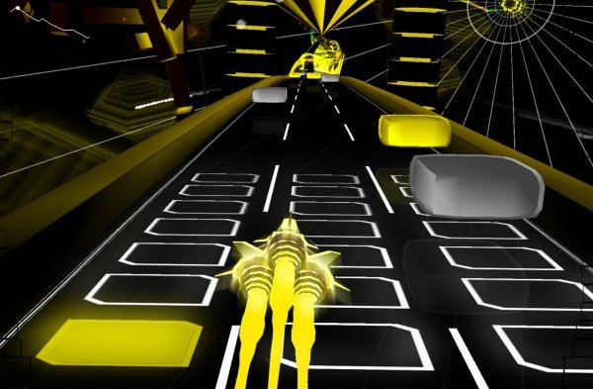

Audiosurf – hit the colored blocks

(Picture Credit: <http://cf.shacknews.com/images/sshots/Screenshot/9145/9145_47a2e93e37577.jpg>)

Liked Features:

* Automatically generated tracks from any user audio file
* Track is somewhat randomly generated, which keeps things interesting
* User can play whatever song they wish

Disliked Features:

* Gameplay of moving the ship left and right is a bit boring
* Lining up colored blocks on the board is tedious for a rhythm game

Audiosurf is another popular rhythm game that’s available for computer, though unlike osu! it isn’t free. The main feature of Audiosurf that separates it from other rhythm games is the fact that each track is generated based on the song itself. There is no user-generated content, as the computer program does it all. The algorithm itself is incredibly complicated (according to the developer), as it does not only rely on beat detection, but other miscellaneous frequency analysis. The core gameplay is to hit the colored blocks, with the objective of filling the board (the rectangles in front of the ship) with the color.

The fun from Audiosurf primarily comes from its “play whatever you want” aspect. It’s fun to watch the computer generate a roller coaster-esque track from your favorite song. This is the element of Audiosurf that I wish to implement in my Term Project. That being said, the complicated analysis that Audiosurf implements is not going to be fully implemented, as analysis of that level is far beyond my understanding, as it would involve more of the analysis of sound, and less of actual coding. Taking the simplest approach, I’ve decided to just use librosa’s beat detection feature, and generate a random map using those beats.

The main gripe I have with Audiosurf is the lack of engaging gameplay. After a few songs played, the gameplay gets stale fast. That is why I have decided to omit the gameplay entirely, and implement the gameplay of osu! (as described above) instead. In a sense, my Term Project separates itself from osu! and Audiosurf by being a hybrid of both.